**UiPath Integration Service: ServiceNow Integration**

**NOTE**:

1. In SNOW:

* plugin->OAuth2.0 should be active
* Oauth->Application registry -> enter name, client ID & client secret (auto-generated), redirect URL (SNOW authentication documentation)

1. Connect to SNOW in Integration Service by entering Site URL (above SNOW instance URL), client ID & secret (generated in above application registry)
2. Install SNOW package compatible with CLOUD.
3. Create trigger when needed & reduce polling time in Connection.

Go to Integration service & select the MODERN folder where you want to have the connector. In connector tab, search for Service & click on it as it appears.

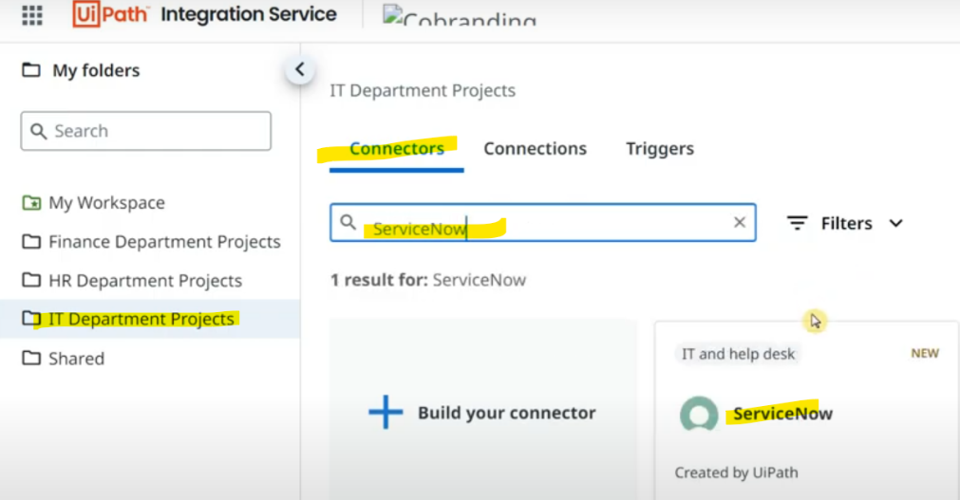

Click & keep the documentation open for your understanding.

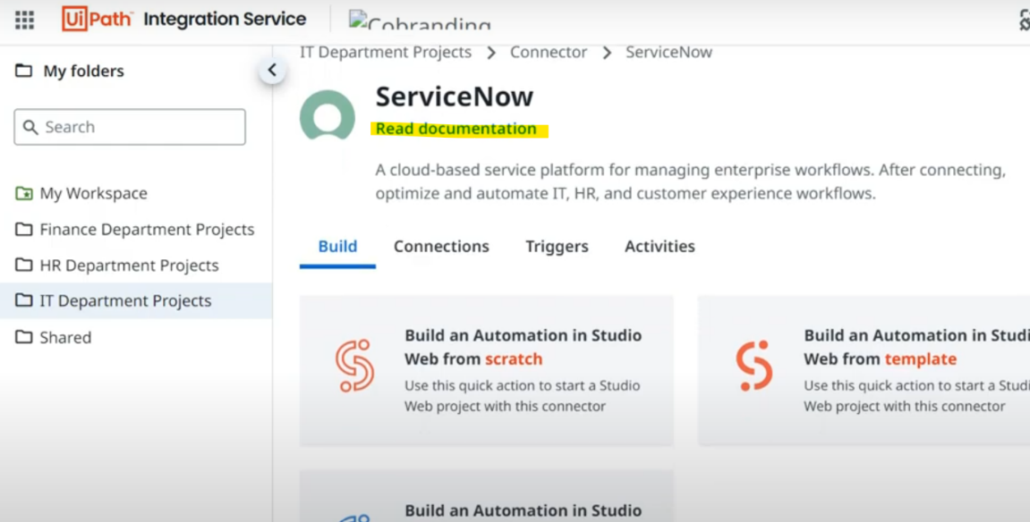

To integrate SNOW, you need to have an account. Type "Servicenow free account" in google & click on below site.

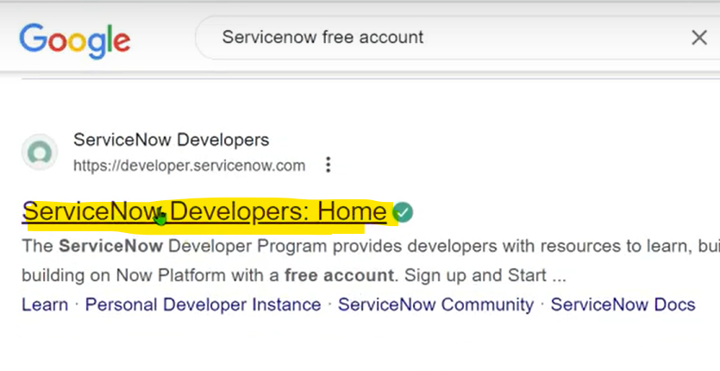

Open this & click on.

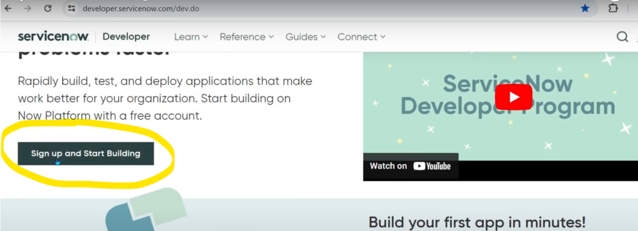

It asks for couple of things like below.

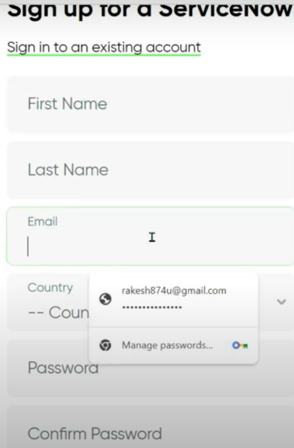

This is how it looks after you have built an instance & logged in. Click on "Start building arrow"

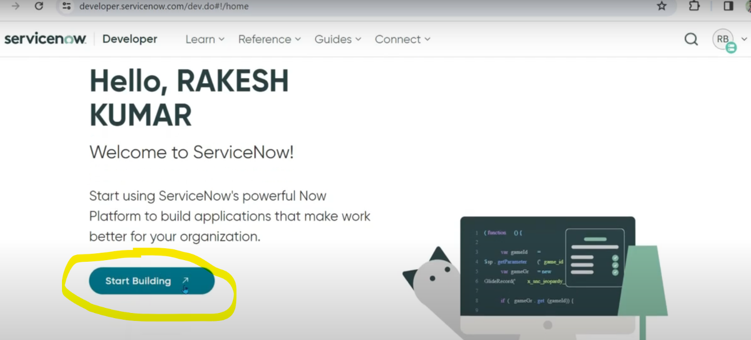

This takes us to another webpage where it will have built us a DEV instance.

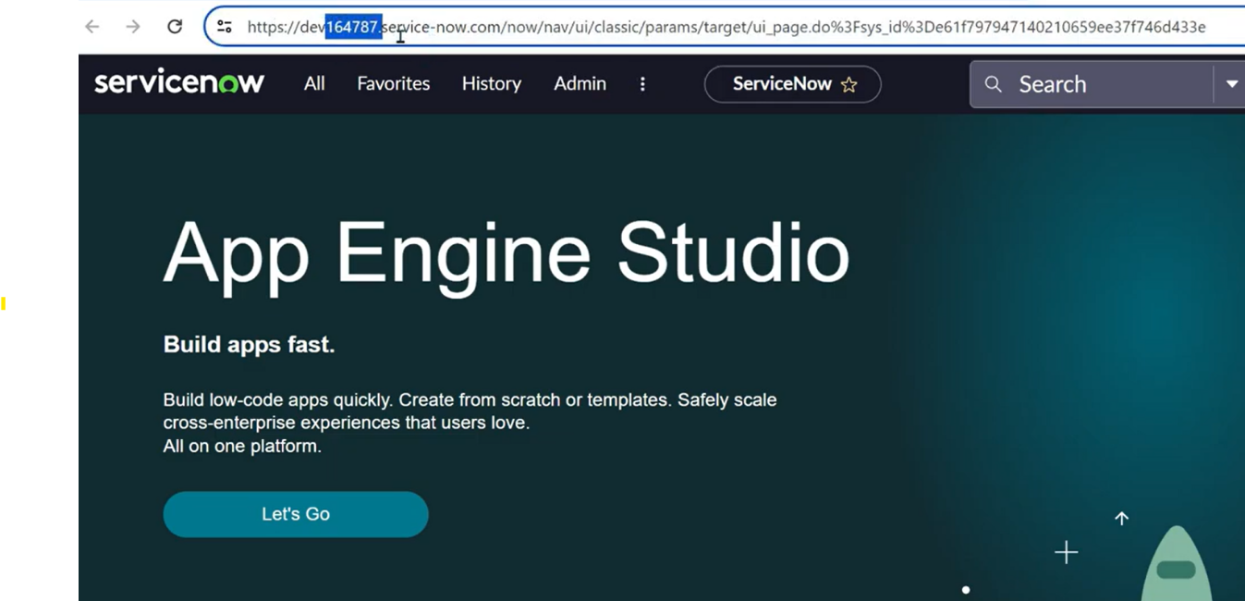

If you want to create an incident, search for it & you will get the incident menu.

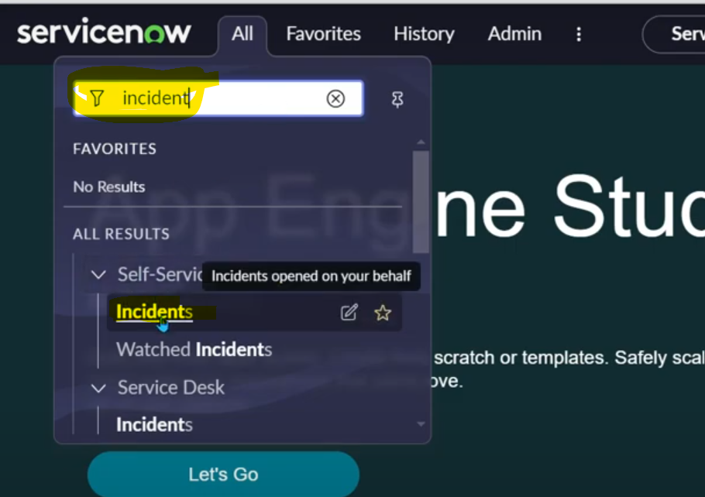

Click NEW to create a new incident.

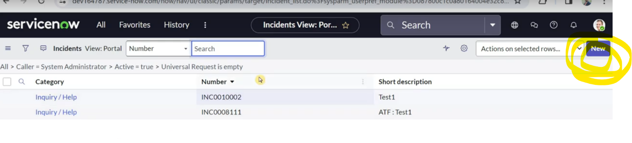

Now you can create a new incident by filling in the details.

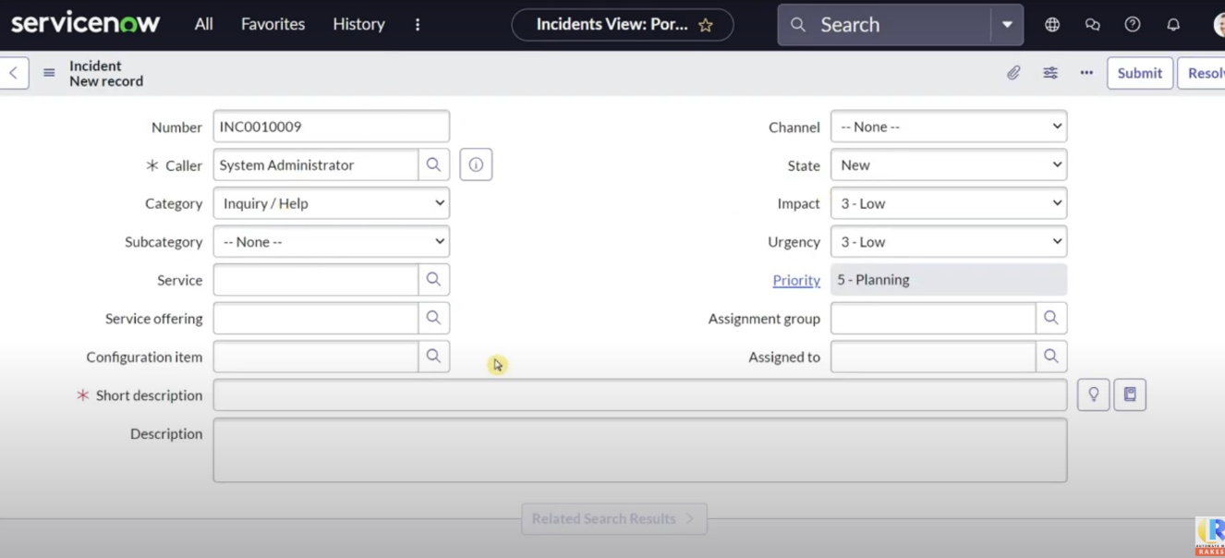

Here our job is to integrate Uipath with ServiceNow & perform actions. Once you have selected the card in Integration service, click on Connect.

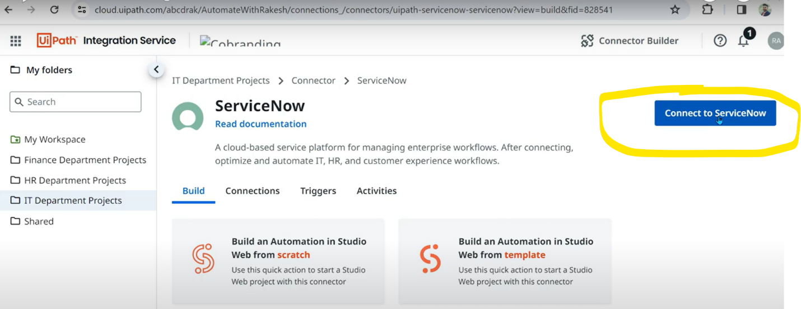

Below is the page we see.

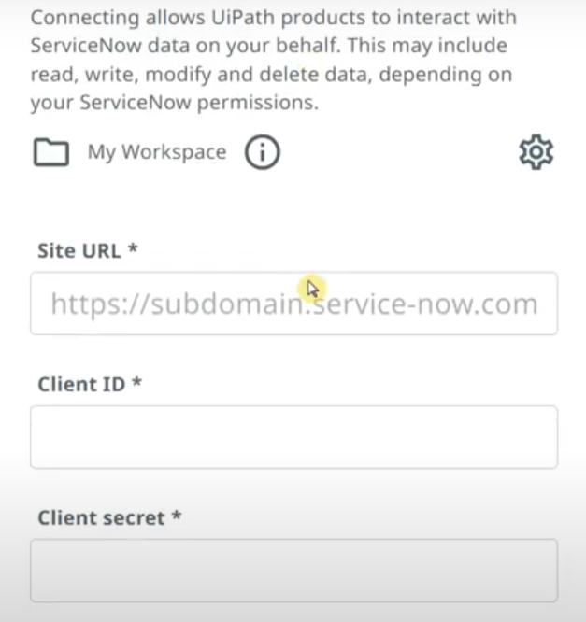

To fill above fields, go to SNOW, in ALL, type plugin & select.

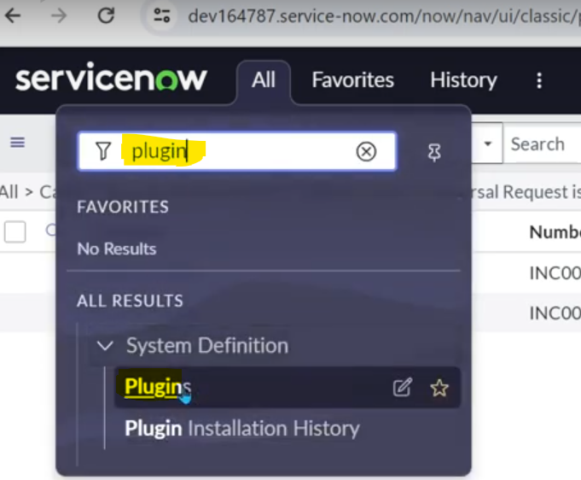

You now get the below popup.

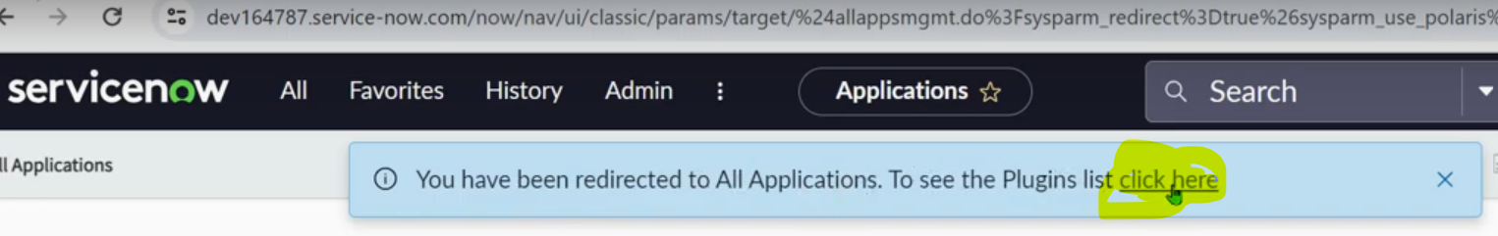

In the list of plugins we need Oauth (Open authentication)

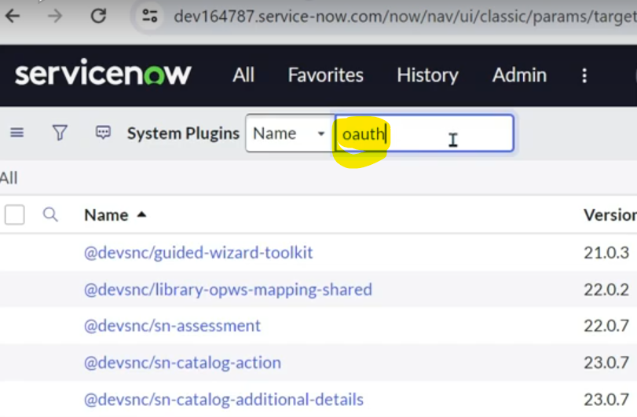

Select the below one.

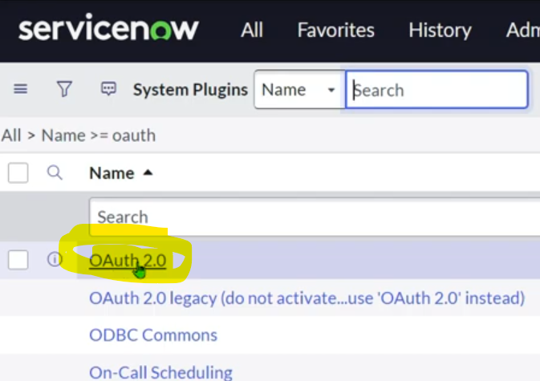

Upon entering inside Oauth plugin, we should see the status ACTIVE.

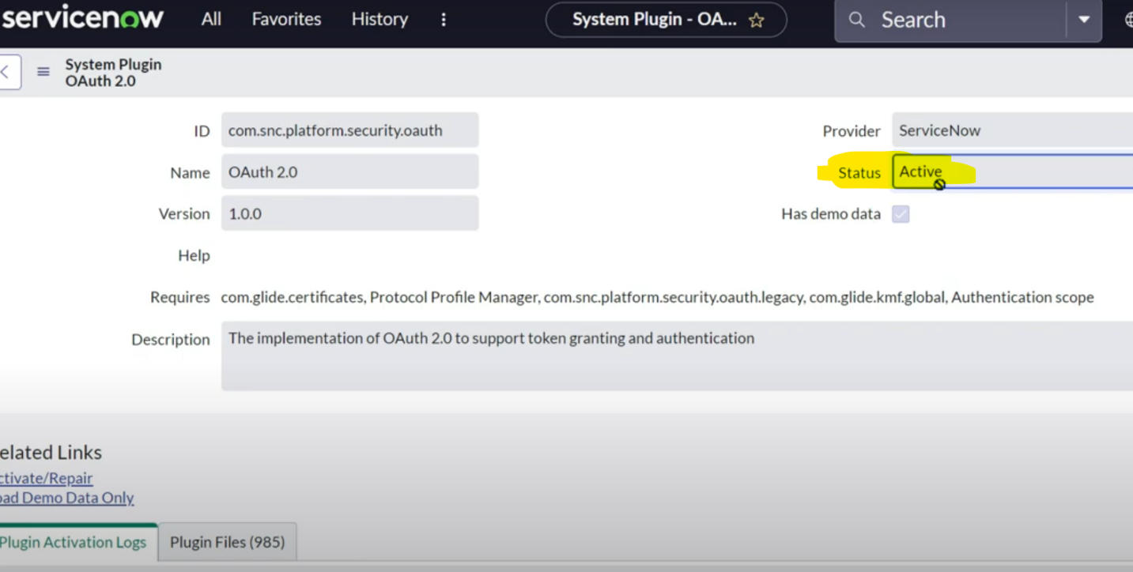

GO to ALL -> search Oauth & select Application registry. Here we will build a connection with our application. Let's register UiPath in SNOW.

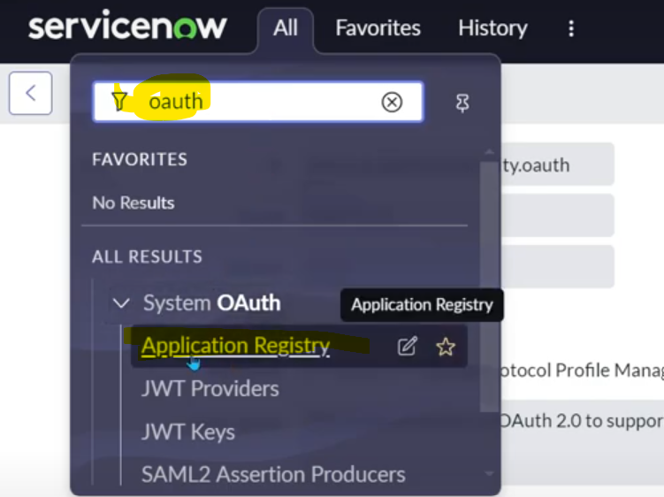

Click on New.

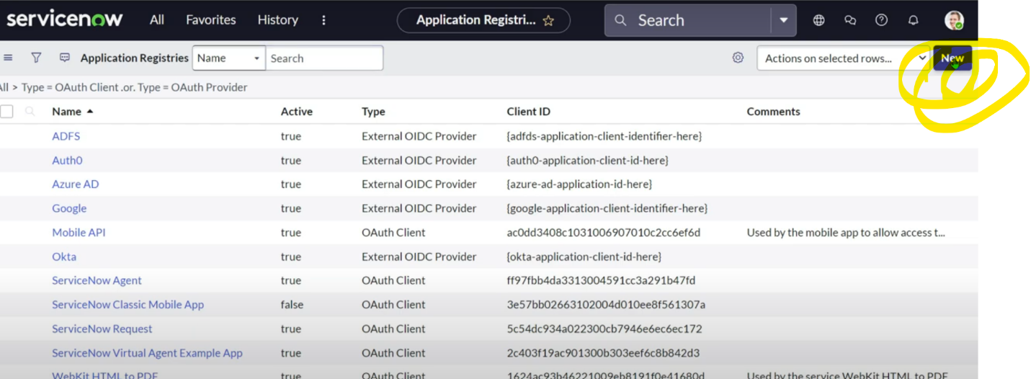

Click on "create an Oauth API endpoint for external clients". Our UiPath is an external client to SNOW.

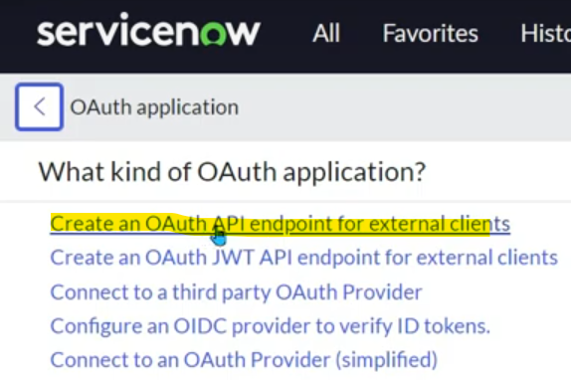

Fill the below form.

Client secret: autogenerated.

Client secret: to be left blank as it gets automatically generated.

Name: UiPath Integration (of your choice)

Redirect URL: To send back the incidents or info, we need to specify to where SNOW should send.

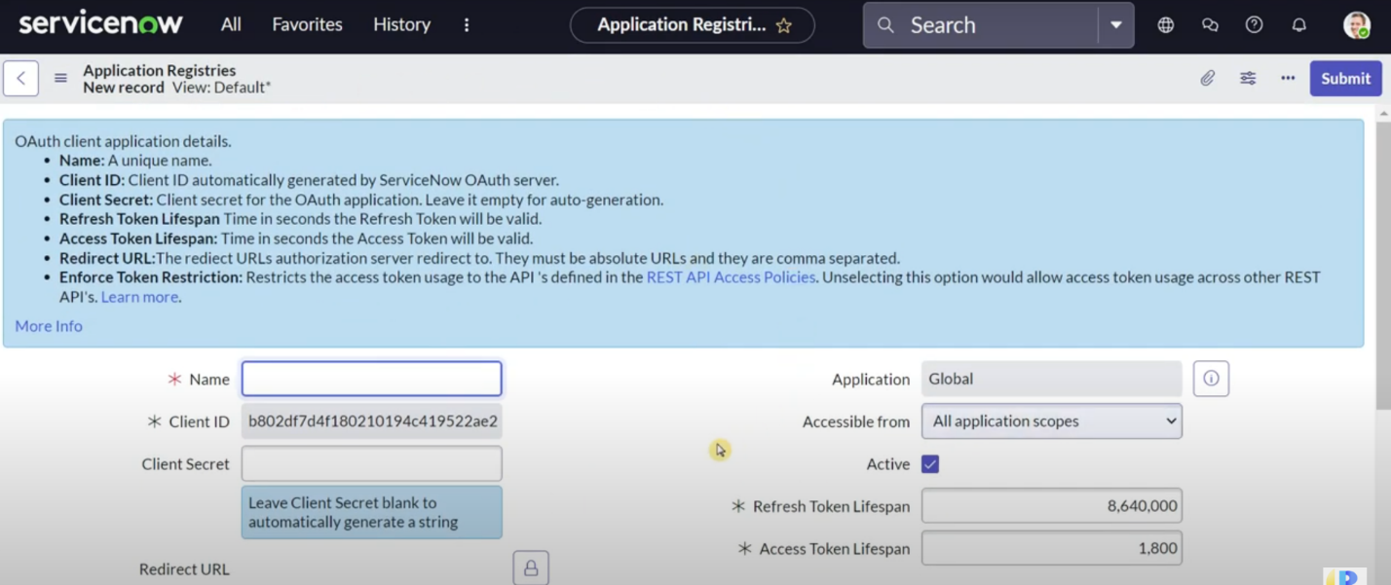

To get Redirect URL, open the documentation which we kept open before connecting on Integration Service. Click on "ServiceNow authentication".

It describes all the above steps we did till now. Here we will find the URL

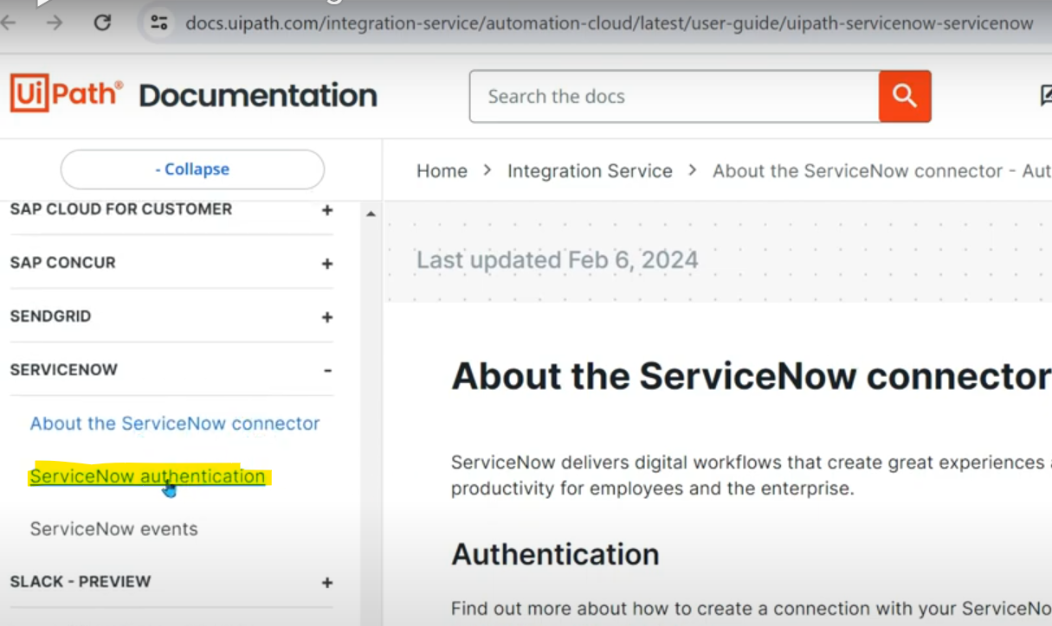

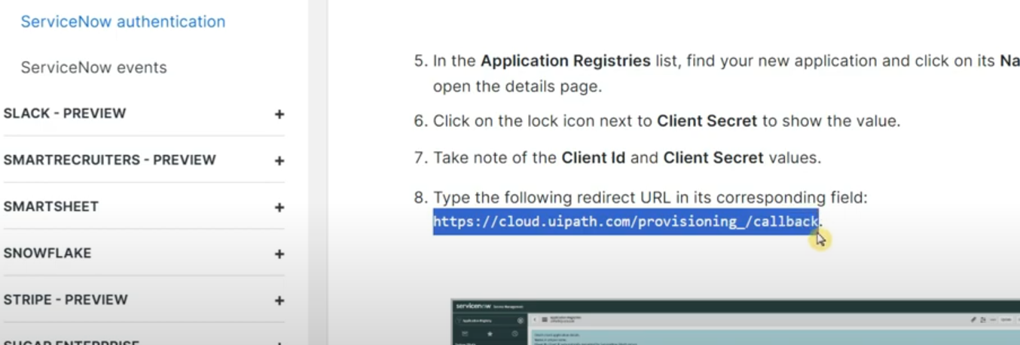

Now it understands where to send the information.

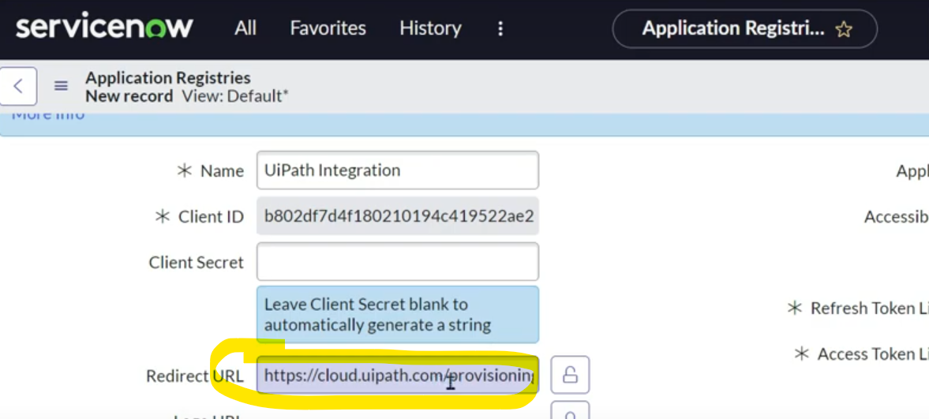

Hit on submit.

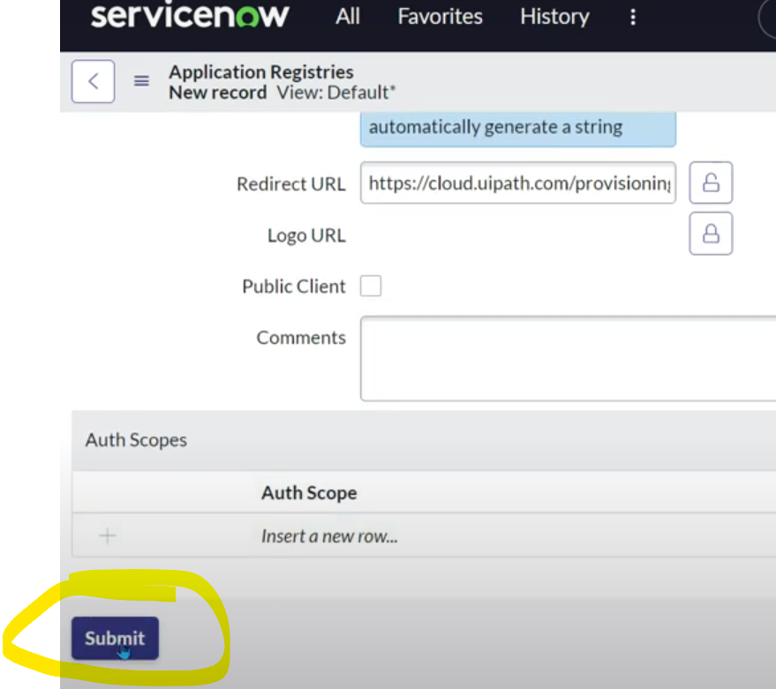

Now we have registered UiPath application with the URL & client ID has got generated.

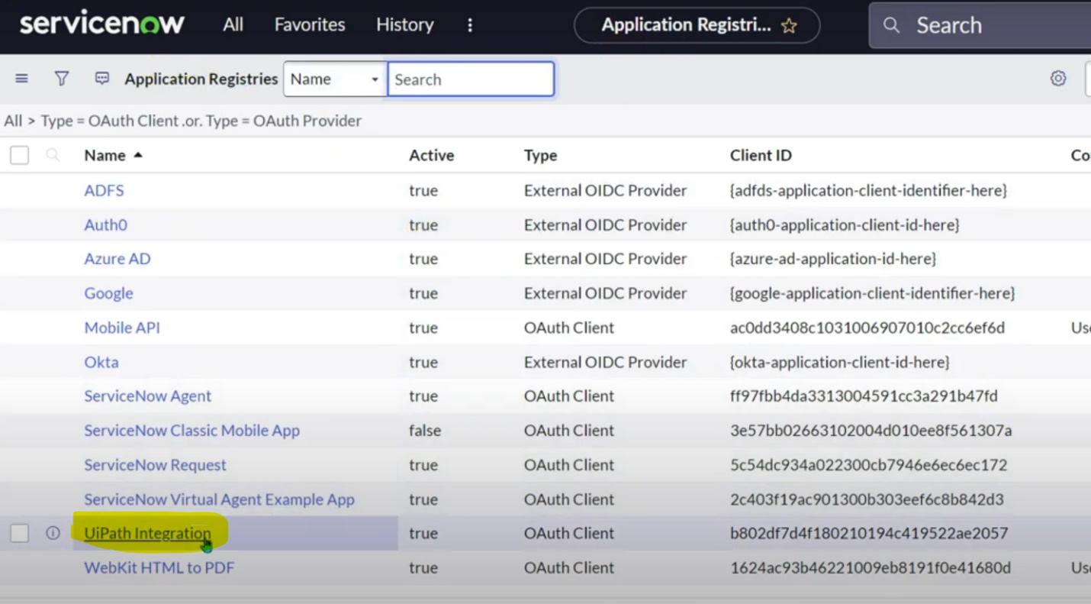

If you click on it, you get to see client secret autogenerated.

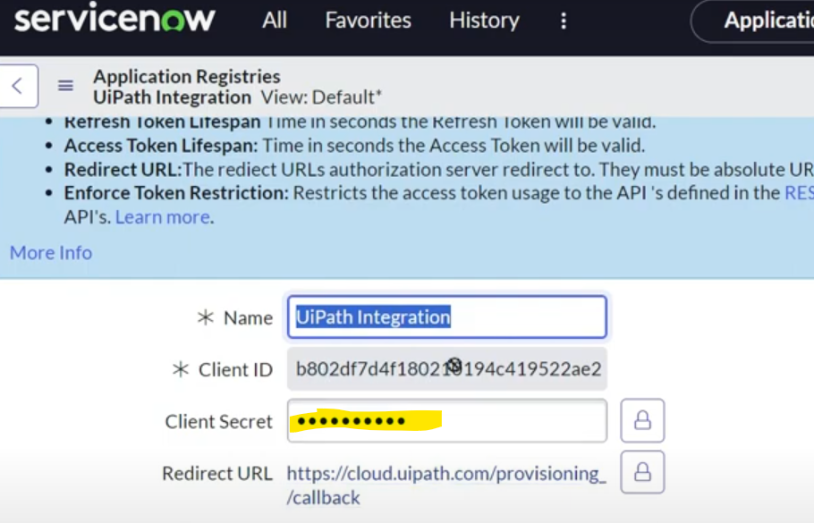

We enter this client ID & secret in Integration service wile connecting.

Fields to be entered are: Client ID, Client secret & Site URL.

Site URL: Your SNOW instance URL, only blue highlighted part below.

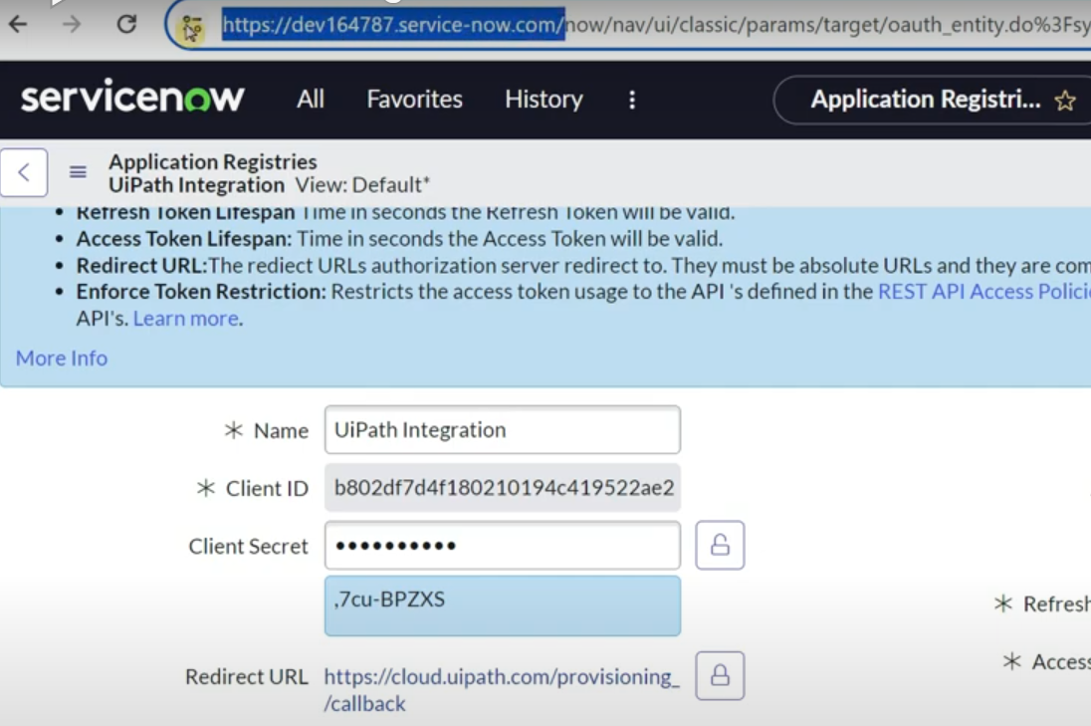

Paste all the details & click on connect.

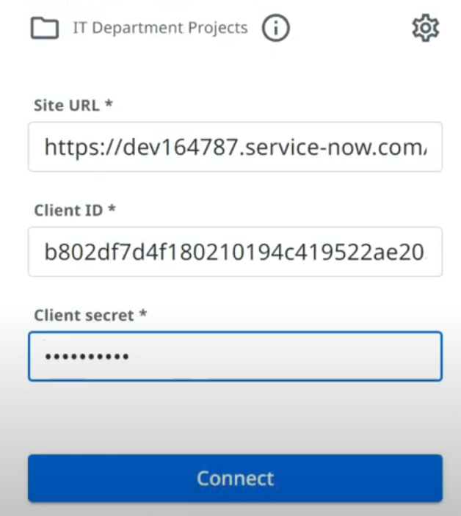

It asks you to connect by showing the SNOW instance number, click on Allow.

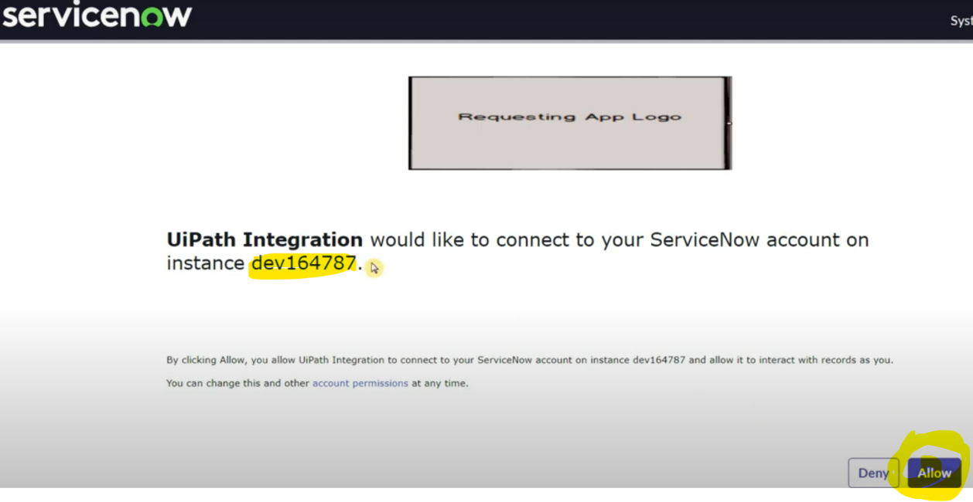

In the Integration Service, connection tab, you will see the connection active by showing connected.

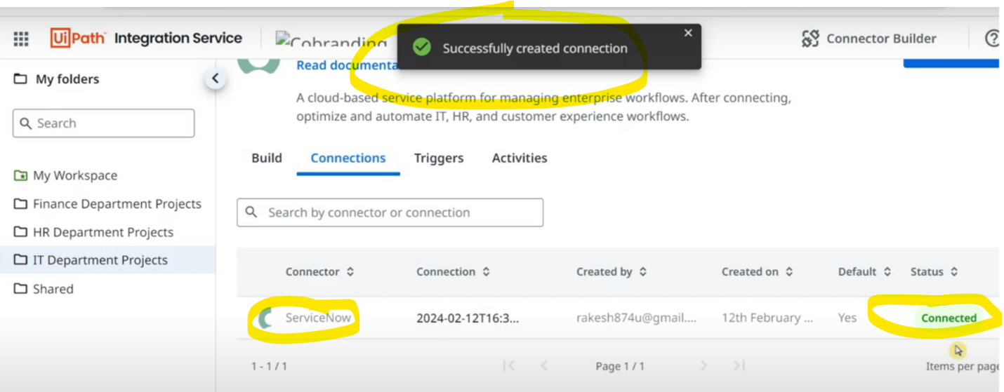

Connection has been made, now let's build a small project. Before that install the dedicated package (**check for CLOUD compatibility**)

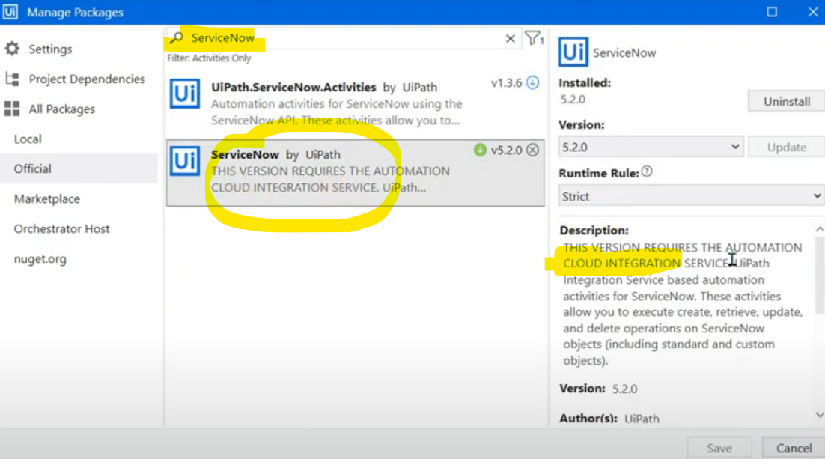

Below are the dedicated activities.

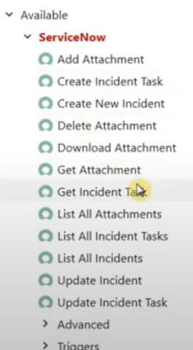

Let's create an incident. Here it understood, using Integration service, your account has connected to SNOW & it has checked if connection is available & automatically it has taken the SNOW instance.

Below is the SNOW connection.

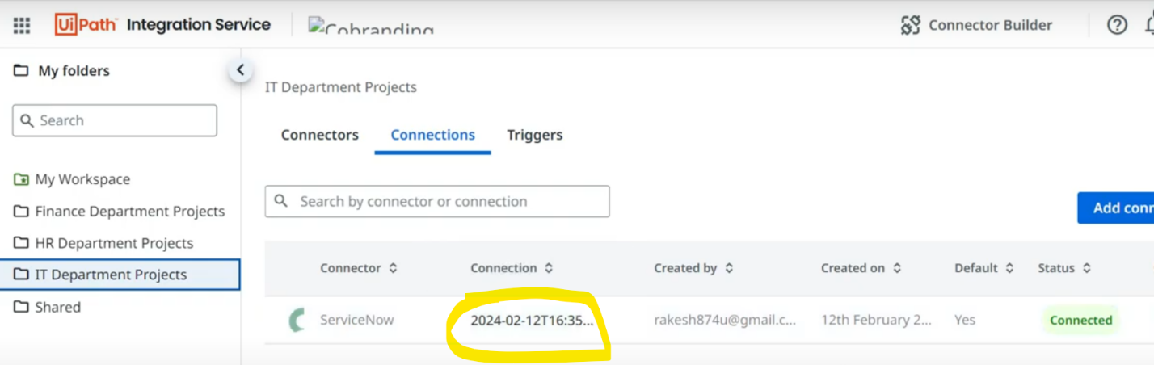

The same connection data has been taken by uipath activity.

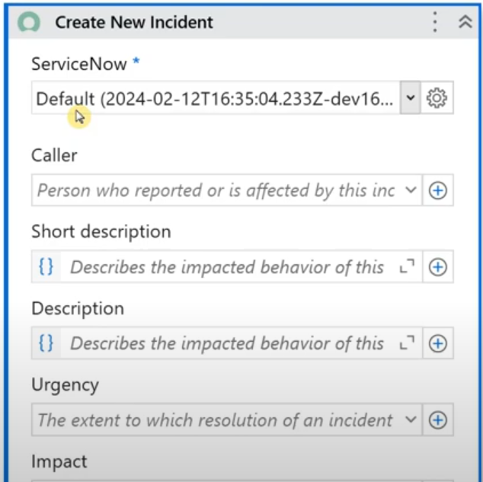

Caller: It has got a history of callers & as it is DEV instance it has too many options. If it is Production, it will have our own database of users from where the names will reflect here.

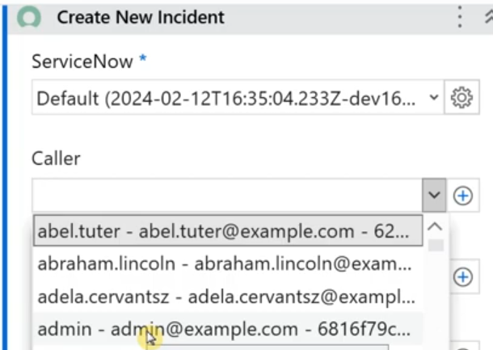

Fill other below fields.

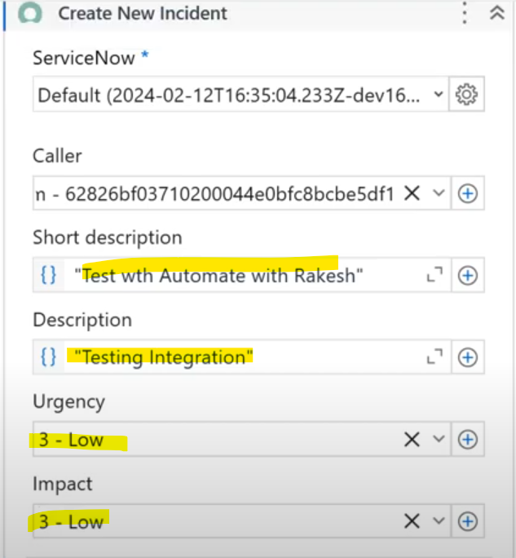

Once incident is created, to get its number, create output variable in properties. Also use Log message activity to print this incident number.

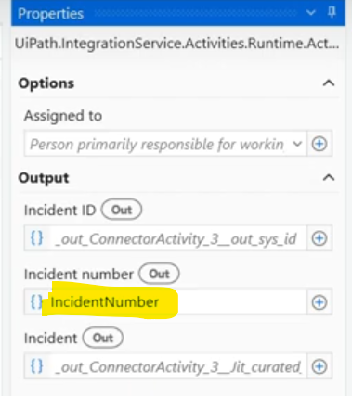

This activity is now supposed to create an incident in our SNOW. To see incidents, go to SNOW, type Incident & click on it.

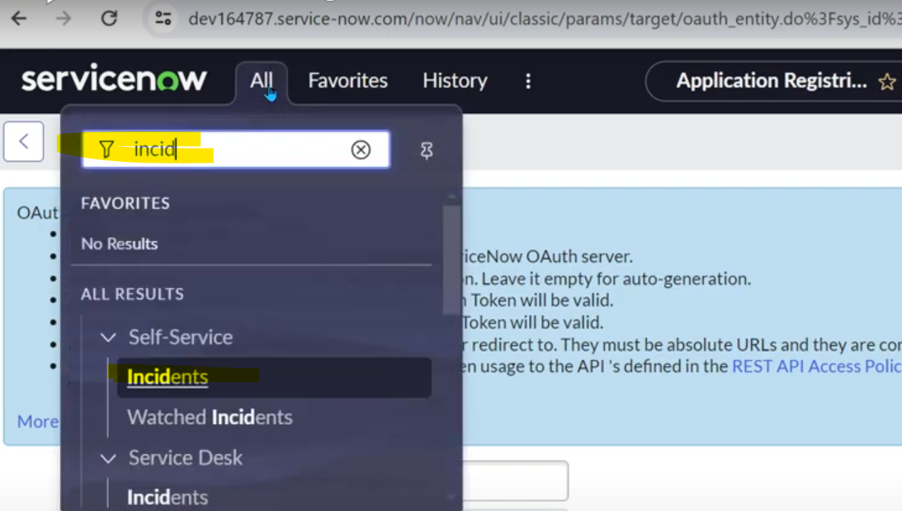

You will find the incidents page.

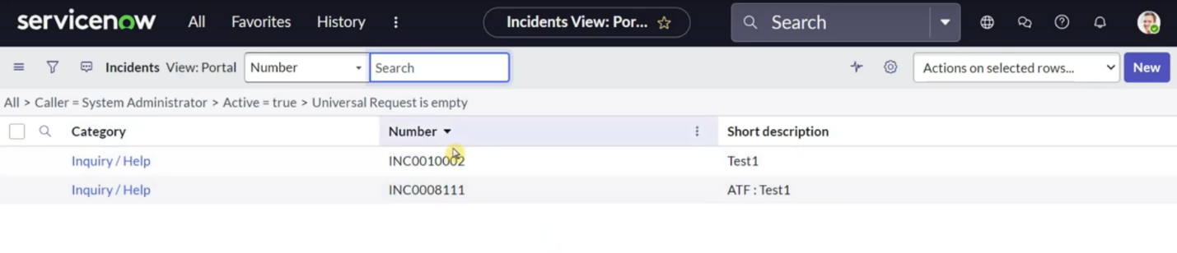

If you click on All, you will be able to see all the incidents.

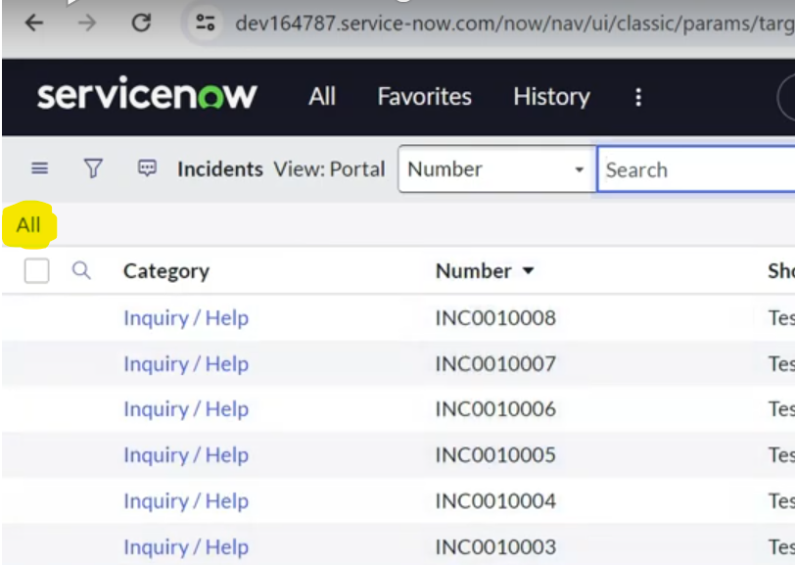

Run the automation & refresh your SNOW incident page, you will see the new incident you created using uipath studio, you can verify from the description you see, open it.

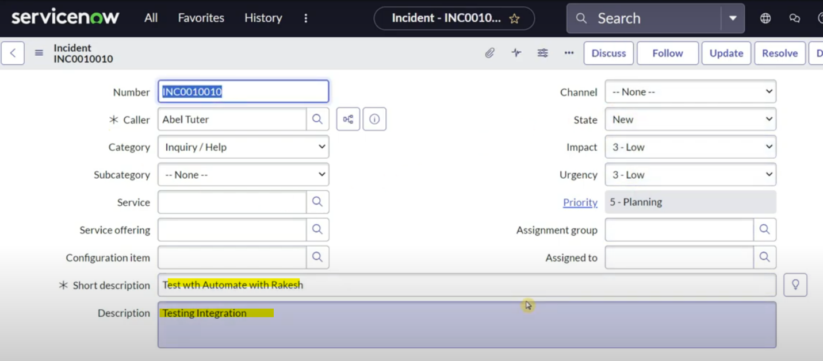

**Now, let's learn how to start an automation if someone created incident on SNOW.**

We need to create trigger for this. Add trigger & enter the below information.

Select connector: type ServiceNow

Connection: automatically takes connection name

Event: In Event there are multiple choices like Incident updated, Record created/updated and many more.

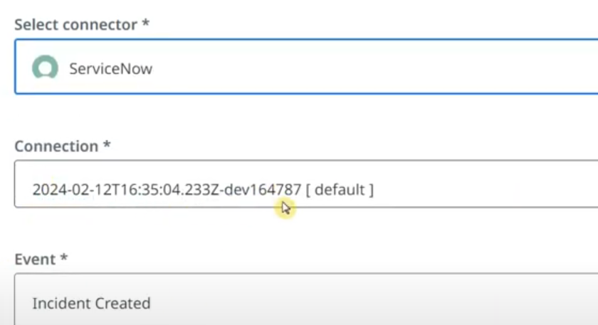

Select automation & Runtime license & click on Add trigger.

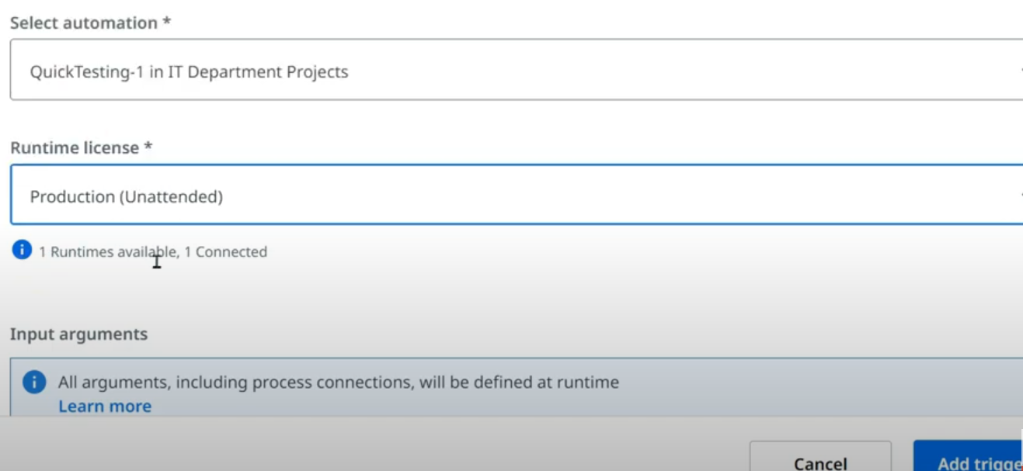

Now the trigger is created.

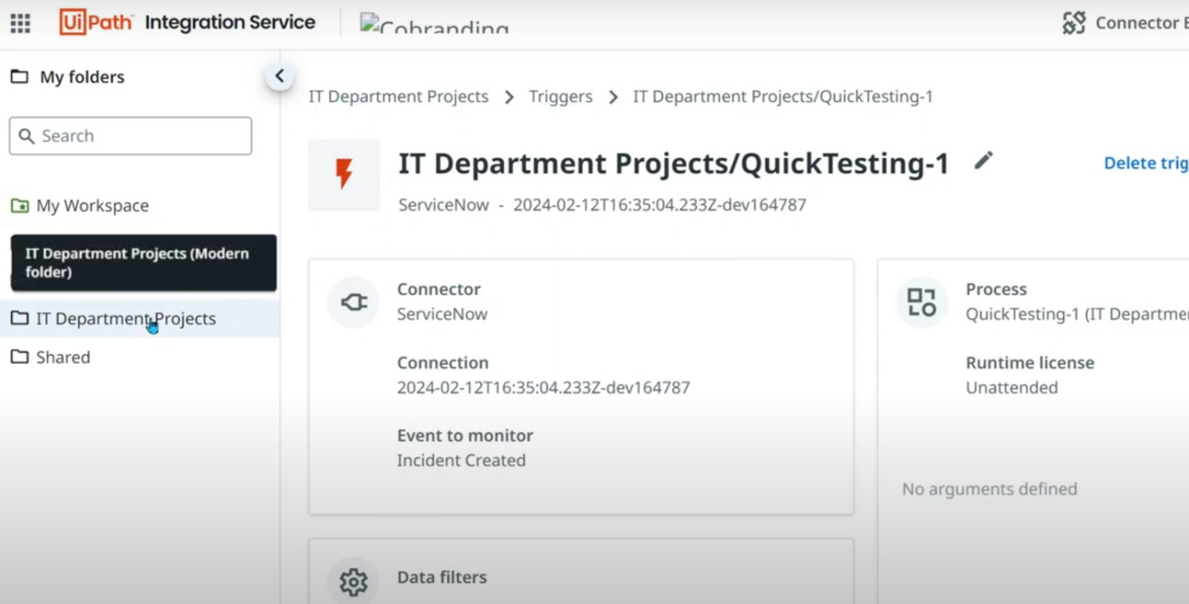

As we are doing trigger testing, let's change the polling time to 1 minute in the connection.

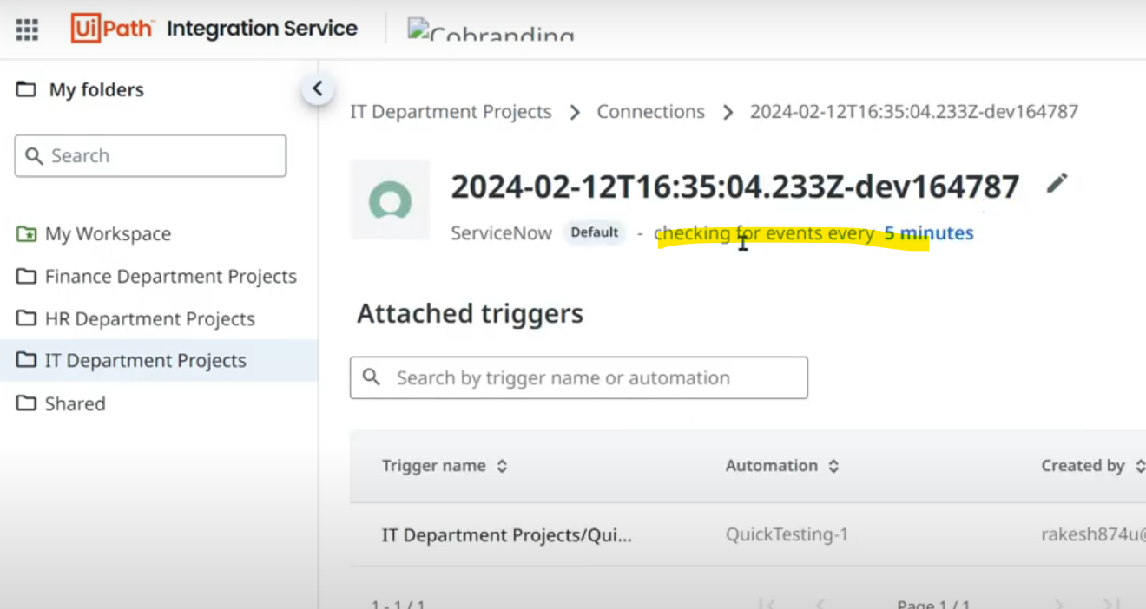

Let's create an incident in SNOW & see the trigger history. As trigger is active, it will automatically starts on its own & check its history to see if it has run, also we will get output from studio as message box (as per the code).

